**Upgrading an Outdated Website**

**Created by: Geraldine Kelly**

**OVERVIEW**

By 2030 the demand for employment involving gerontology will greatly increase, especially as Baby Boomers start to become senior citizens. One attempt to resolve this incoming issue was a blog called *Exploring Careers in Aging –* originallybuilt by Linda Wiener*.* Since 2005, the *Exploring Careers in Aging* website has provided information for prospective college students who may want to work with the older population as a profession, however the only way this website can be found now is through the Wayback Machine and is - by HTML5 and CSS3 standards - outdated. For my Capstone Project, I volunteered to rebuild the Exploring Careers in Aging website from the ground up with mobile-first and responsive web design in mind.

**PROJECT DESCRIPTION**

The primary goal of this project is to create a new website that can be easily viewed with mobile devices and modern web browsers. Imagery such as page-specific banners, a brand logo, and a favicon have also been created for the new website. The new Exploring Careers in Aging website will be a guide for students and professionals on the many careers that may (or may not) be closely related to the field of gerontology.

**Purpose:**

The new Exploring Careers in Aging website will not only provide information on careers that are closely related to gerontology, but also careers that are loosely related to the field. This website will be targeted for current or future students who wish to study gerontology and will also give information for employers and job seekers. It will bring this information to a modernized form that can be accessed through both personal computers and mobile devices.

**Technical Features:**

The brand-new website includes:

* The **Navbar Menu** gives links to other pages of Exploring Careers in Aging **(Figure 1)**, including
* An **About Us** page including the history of the site, a summary of who the website is for, and a guide to how to use the website.
* A **Gerontology** tab that explains what the study of aging is and provides information on combating ageism.
* The **Students** tab which can give students information about jobs they can find with a gerontology degree and where they can study gerontology.
* The **Job Seekers** tab provides links to websites such as LinkedIn and UNCW’s Career Center webpage.
* An **Employers** tab that will convince employers to hire people who have studied gerontology and tell how to find those people.
* The **Community Partners** tab will give information about internships and practicum students.
* The **Social Media** tab will give links to ECA’s presence on other sites and also a link to the Old School Clearing House website which has similar goals to Exploring Careers in Aging.
* A **responsive design**, meaning the website can easily adapt to smaller screens like those of phones and tablets and follows the current HTML5 and CSS3 standards. It will also use the Bootstrap framework to make the website responsive and speed up the process of development **(Figures 2a & 2b).**
* A unique logo with a motto below it and a favicon that closely resembles the compass in the logo **(Figures 3a through 3c)**.
* A series of images with a consistent art style for each webpage about a specific career **(Figures 4a through 4p)**.

**Software and Hardware:**

I created the website with Adobe Dreamweaver which provides templates with Bootstrap 4 coded into them **(Figure 5)**. From there I adjusted and customized the template I chose to fit my needs. The visual aspects for my project used Adobe Illustrator. Before going to Illustrator to make the final logo for ECA, I made some rough sketches to come up with a design that my client and others involved in the project would like. The final product was conceived on paper after looking up some reference images of compasses when I realized that the word *exploring* started with an E, just like the one commonly found on a compass that stands for *east* **(Figure 6)**.I used Adobe Color to determine a color scheme for each of the images used for various career pages.

I have used three different computers depending on where I was on campus. I used my own HP laptop with an Intel Core i7-7500 CPU processor, an Apple desktop computer from the Randall Hall Library, and a dual screen PC that runs on Alien hardware located at the Digital Arts Lab in Congdon Hall. I used a generic thumb drive that can hold up to 14 gigabytes of data to work on my project from any one of these computers.

**Issues Encountered:**

The issues experienced during the production of this project include:

* Making nested 2nd, 3rd, and 4th tier dropdown lists for the navbar **(Figure 7).**
* Coming up with ideas for banners for the following career pages:
* Human Resources
* Administration
* Financial & Legal Services
* Insurance Agents
* Advocacy
* Real Estate
* Leisure & Recreation
* Marketing
* The HTML of the main page became corrupted after I was trying to edit it with a different program on an Apple computer after I found out that I could not access Dreamweaver. I had an earlier backup of the file on my personal computer, so I had to update that backup file with all the recent changes at the time.
* Finding out the next steps for the project from Dr. Newsham. There were a few other people involved in this project who were working on other aspects of the new website, so it took some time for Dr. Newsham and I to figure out what other things I should do for the project while everything else (such as a Microsoft Excel Sheet listing careers for me to make webpages and images for) was being set up. Dr. Newsham has very little experience with webpage development, so we had to discuss what she wanted to see on her website with examples from other websites.

**Future Work:**

The new ECA website will have to be updated and maintained if there are to be any news or events happening concerning gerontology and careers. We will also have to use a hosting service such as WordPress in order for the website to be accessed publicly online.

**Figure 1 - The navbar on a desktop browser.**

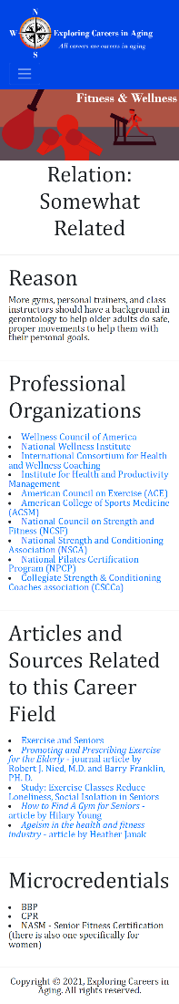

**Figure 2a – Mobile format.**

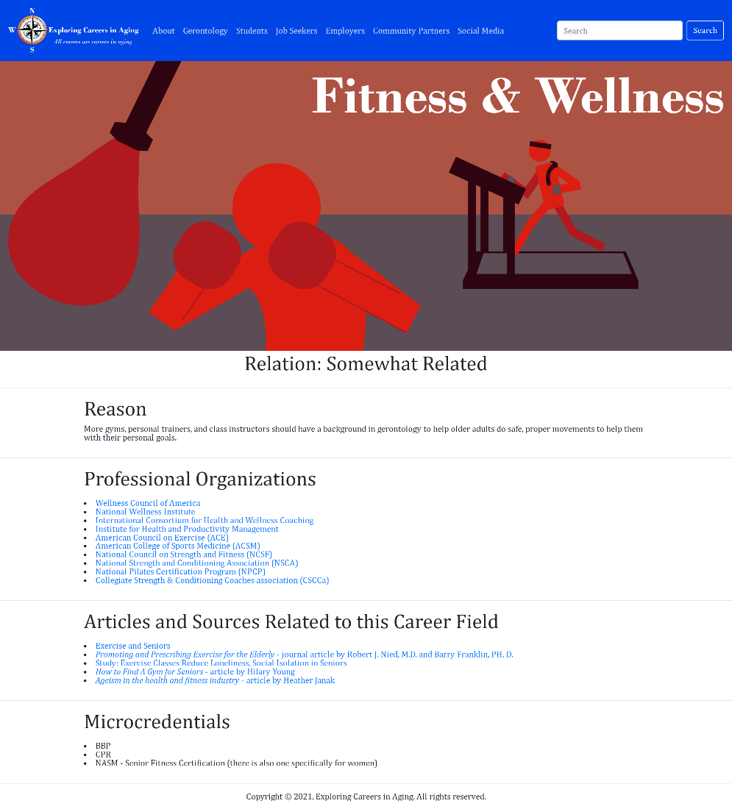

**Figure 2b – Desktop format.**

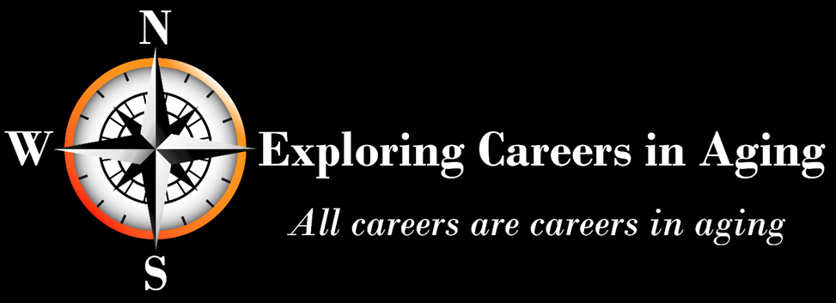**Figure 3a – Website logo with a slogan.**



**Figure 3b – Favicon.**



**Figure 3c – The favicon as shown in a browser tag.**

**Figure 4.1**

**Figure 4.2****Figure 4.3****Figure 4.4****Figure 4.5****Figure 4.6**

**Figure 4.7****Figure 4.8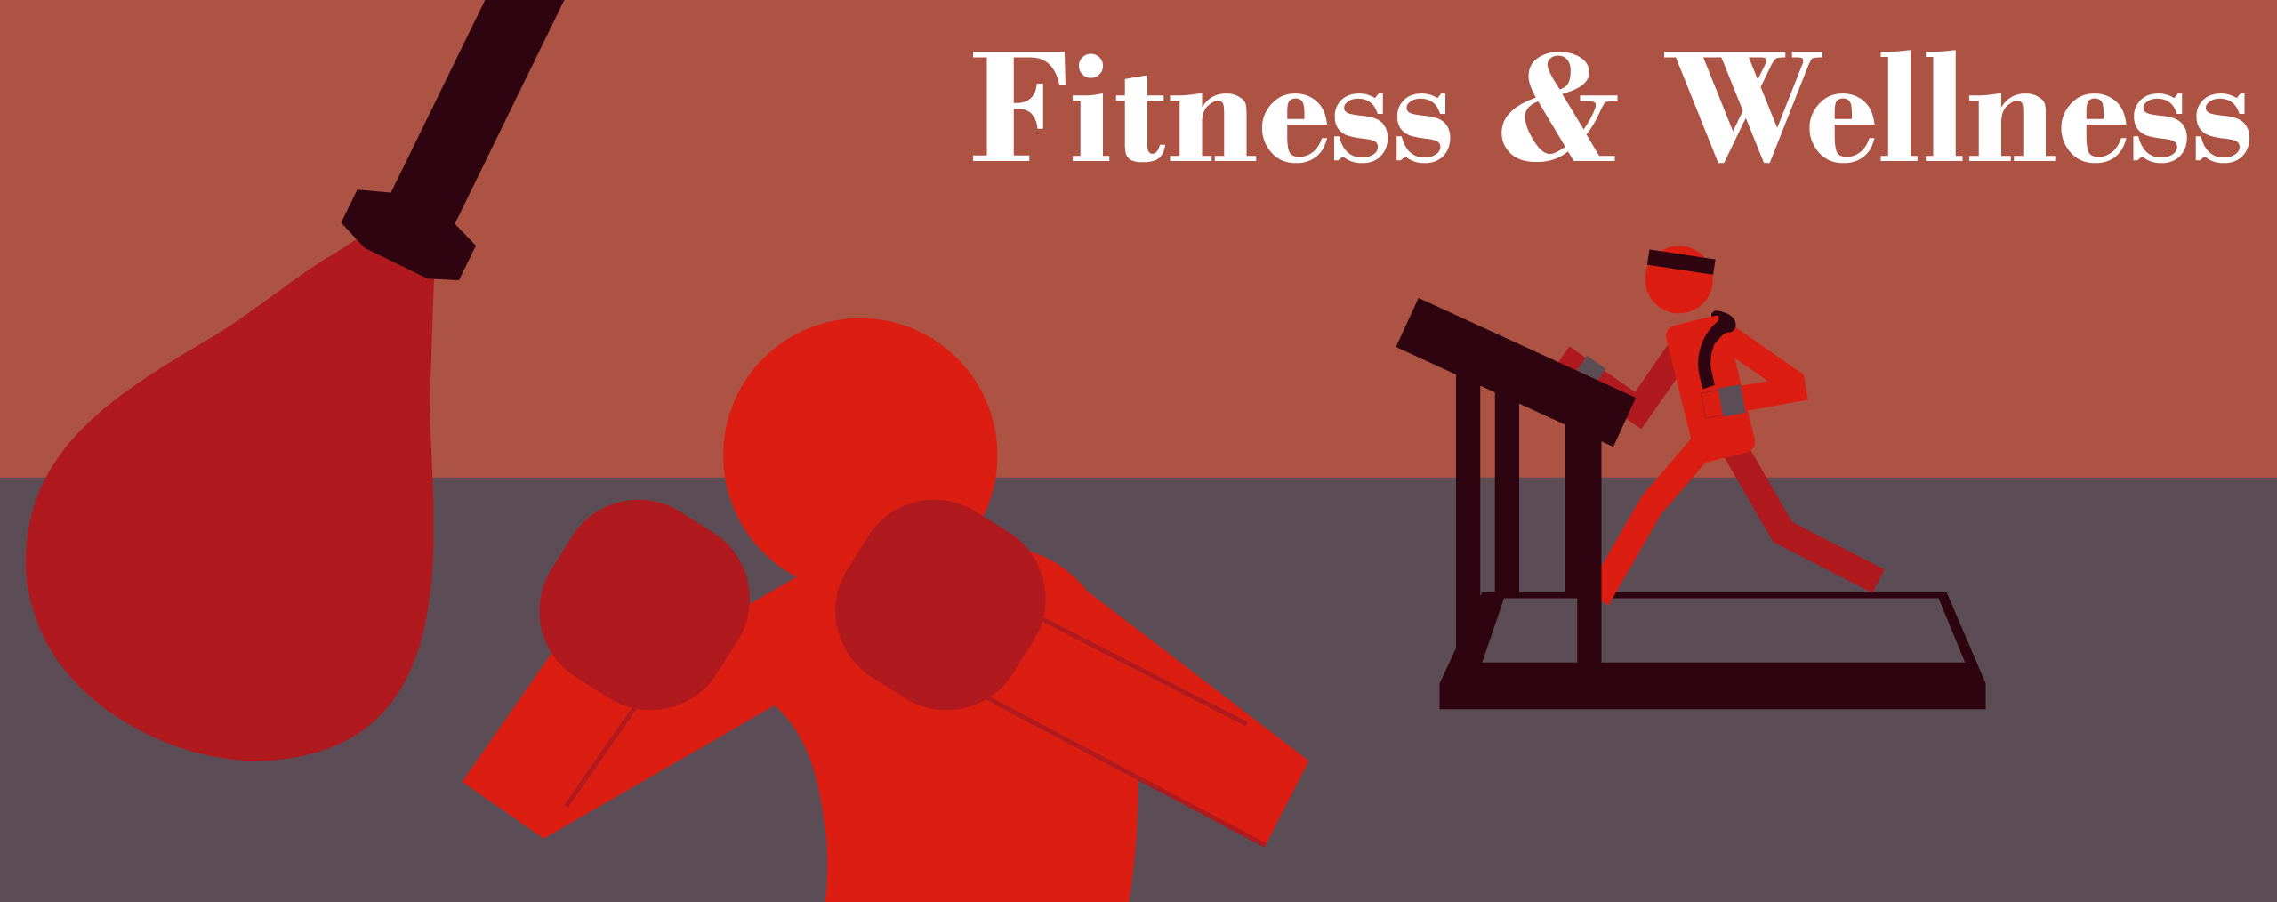Figure 4.9**

**Figure 4.10**

**Figure 4.11****Figure 4.12****Figure 4.13****Figure 4.14****Figure 4.15****Figure 4.16**

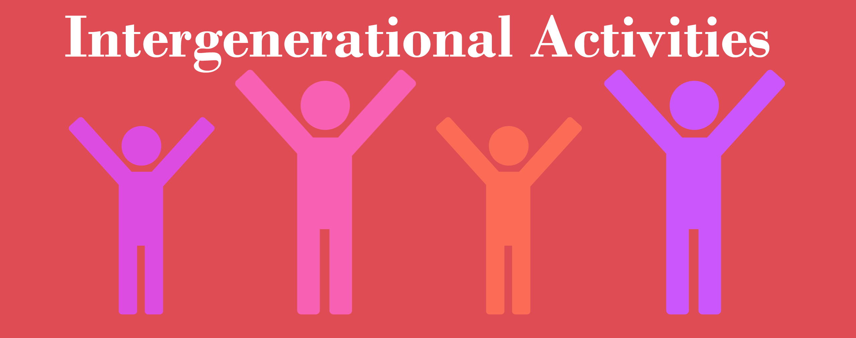

**Figure 4.17**



**Figure 4.18**



**Figure 4.19**



**Figure 4.20**



**Figure 4.21**



**Figure 4.22**



**Figure 4.23**

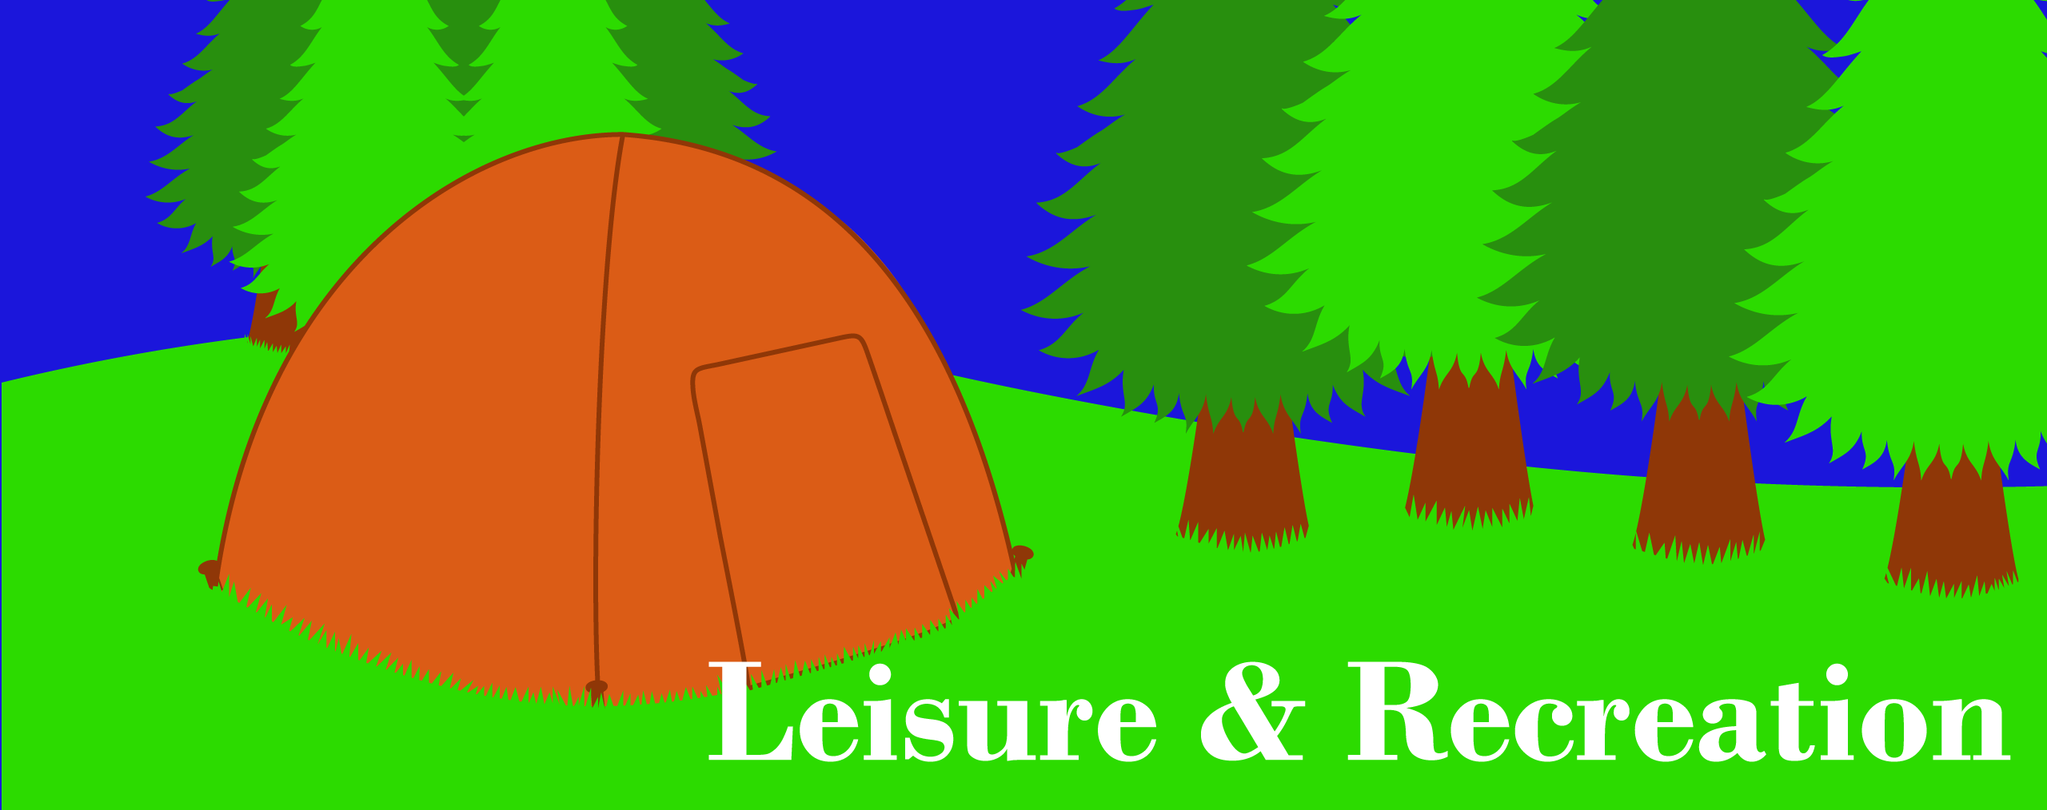

**Figure 4.24**



**Figure 4.25**



**Figure 4.26**



**Figure 4.27**

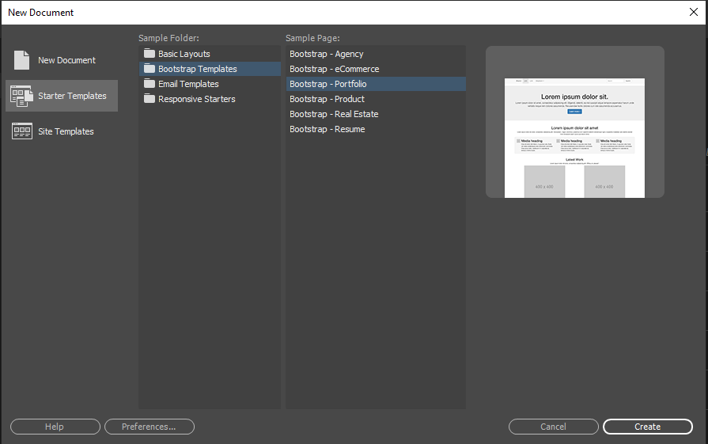

**Figure 5 - Creating an HTML file with a Bootstrap template in Adobe Dreamweaver.**

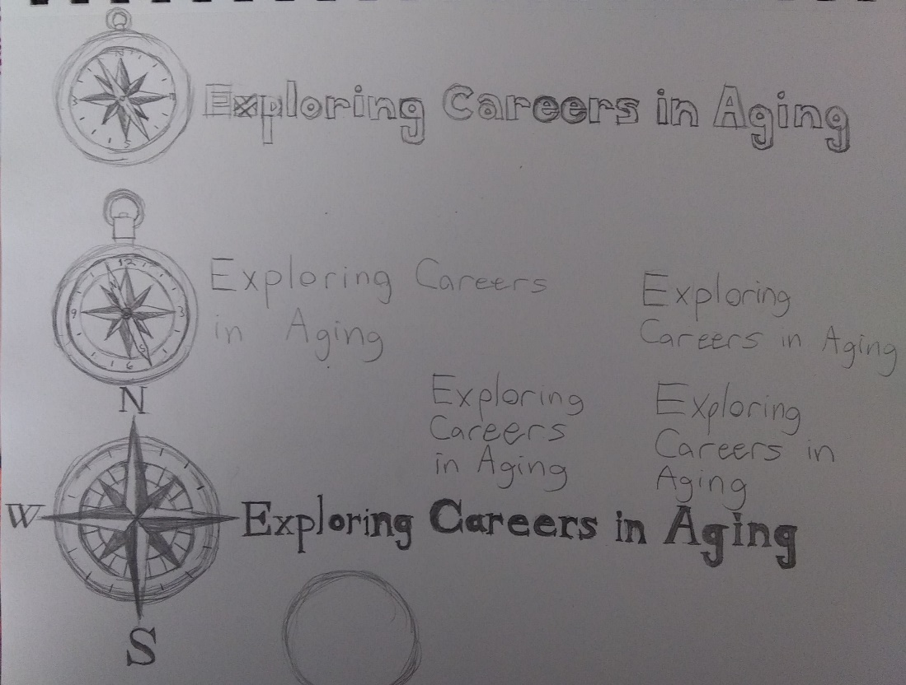

**Figure 6 - Rough sketches of logo designs.**

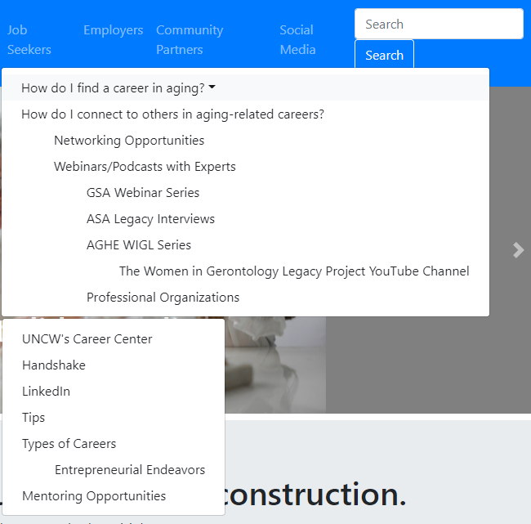

**Figure 7 – Nested dropdowns.**

Citations

1. Boehm, Anne, and Zak Ruvalcaba. *Murach's HTML5 And CSS3*. 4th ed., Mike Murach & Associates, Inc., 2018.
2. "Exploring Careers In Aging". w*eb.archive.org*, 2005, <https://web.archive.org/web/20140519110646/http://businessandaging.blogs.com/>. Accessed 2 Sept 2021.
3. Grabinski, C. Joanne, MA, ABD, FAGHE, et al. *101+ Careers in Gerontology*, Springer Publishing Company, 2014.
4. Knickman, J. R., & Snell, E. K. (2002). The 2030 problem: Caring for Aging Baby Boomers. *Health Services Research*, *37*(4). <https://doi.org/10.1034/j.1600-0560.2002.56.x>
5. "Resources For Interdisciplinary Career Possibilities Exploring Careers In Aging Roadmap". [h*ttps://www.apa.org*](https://www.apa.org/), 2018, <https://www.apa.org/pi/aging/resources/careers/interdisciplinary>. Accessed 2 Sept 2021.
6. Williams, Ellen. *Opportunities In Gerontology And Aging Services Careers*. VGM Career Books, 2003.
7. "W3Schools Online Web Tutorials". *w3schools.com*, <https://www.w3schools.com/default.asp>. Accessed 2 Sept 2021.